Grow Your Private Label and Bulk Business In Europe With The 2018 IBWSS London

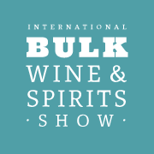
The recent popularity of label wines is an important trend that has important implications for anyone involved in the wine and spirits industry. Most importantly, the growth of the bulk wine business, combined with the growing sophistication of private label brands, makes it possible to unlock new revenue streams.

That ability to unlock new revenue streams is one of the focal points of the upcoming International Bulk Wine & Spirits (IBWS) Show, taking place in London on January 24-25, 2018. If you are looking to grow your private label and bulk business, IBWSS London is your perfect platform to meet private label and bulk buyers.

IBWSS promises to help to change on-trade sector better understand the opportunities and benefits of bulk and bottled in market wine and spirits.

Some of the first keynote panellist and speakers have been announced for what will be the first International Bulk Wine and Spirits Show (IBWSS) to be held in Europe when it looks to bring the trade together to discuss the huge commercial opportunities that now exist for bottled in market in wines in London on January 24-24, 2018.

The event, organised by the American drinks publishing, marketing and B2B networking platform, the Beverage Trade Network, has previously being held in the US, but such is the importance of bulk wine and spirits not just in the UK but in Central and Eastern Europe that it is to host its 2018 conference and exhibition at the Royal Horticultural Halls in London.

Sid Patel, chief executive of the Beverage Trade Network and organizer of IBWSS said: “It is time, we made a private label and bulk trade a norm. London is the most important market for private label and bulk trade, we decided to make London our host city for Europe.”
He added: “The UK is one of the leading store-owned and private label markets, and London the trading capital, so it was obvious that we provided the platform to connect these buyers to top class suppliers from all over the world. who are ready to offer private label services and understand what it takes in being a private label supply partner and help the buyer build their brand.”
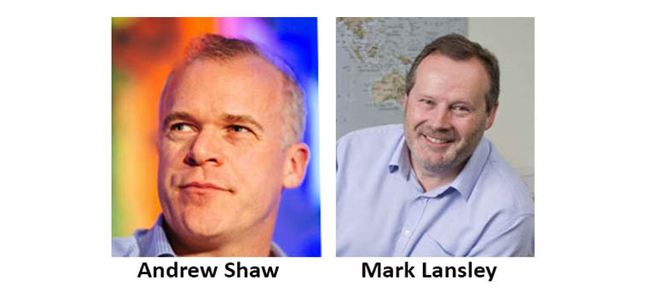

Over the course of two days leading figures from the global and UK wine industry will share their thoughts, insights, and experiences on how bulk wine and spirits can help grow your private label and branded product business. The event will include a combination of panel sessions and 12 TED-style talks, with The Buyer, signed up as one of its strategic media partners.
Confirmed speakers include Andrew Shaw, group wine buying director of Conviviality PLC in charge of managing the strategy of the UK’s most significant wine supplier covering both the on and off-trades through its own businesses including Matthew Clark, Bibendum, PLB, Bargain Booze and Wine Rack. As well as working with third-party retailers, grocers and wholesalers to source bulk wine for exclusive brands and lines.[…Continue Reading].

Location: London

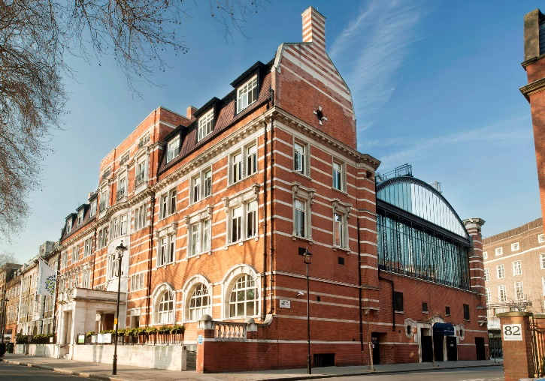
As the go-to shipping in London, the capital of England and the United Kingdom, and home close to the majority of wineries in the UK, London is positioned perfectly for the fair. The city has long acted as the UK’s trading post. With the launch of IBWSS, international bulk suppliers from some of the world’s most important markets will have unprecedented access to the US market.

WHERE AND WHEN

January 24-25, 2018.
The Royal Horticultural Halls, 80 Vincent Square, London, SW1P 2PE

EXHIBITOR PRICING AND TERMS

EARLY BIRD - £2200 (July 1 - August 31)

REGULAR - £2600 ( September 1 Onwards)

CANCELLATION POLICY

Full refund if you cancel before August 31. After that 50% refund.

EVENT PRODUCER

International Bulk Wine and Spirits Show is brought to you by Beverage Trade Network, the leading online platform dedicated to connecting the global beverage industry. Beverage Trade Network (BTN) successfully connects wineries, breweries, distilleries and brand owners with international importers, distributors, brokers and beverage industry professionals on a daily basis. Strong partnerships with international and US organizations have helped BTN establish IBWSS as a premiere sales and marketing event committed to connecting the private label and bulk beverage industry.

LIMITED EXHIBITOR SPOTS AVAILABILITY

The event will offer 70 spots, so space is limited. Exhibitors are encouraged to reserve space early as booths are expected to sell out quickly. Table selection is on first come basis. Once you register, you will get to select your own table location.

SET UP INCLUDES

The show is a trestle table set up, you will not pay anything extra for chairs and tables and wifi. Your pricing overs ALL costs associated with the show. You are required to bring in one roll-up banner only and can put marketing material on your table.

IBWSS will provide you with the below.
Tasting Table
White Tablecloth & Skirting
2 Chairs + Ice Bucket + Spittoon
Glasses will be provided to buyers at the show

Exhibitors are encouraged to book before August 31 to secure special rates. Please register here to secure your spot.

For Questions: Email nick@ibwsshowuk.com or call 0203 8580159

